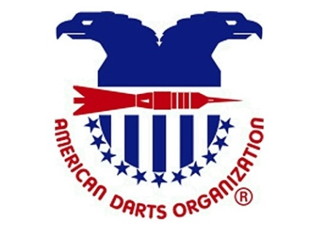
DART REBELS OF WICHITA &
HAYSVILLE VFW
POST 6957
INVITE YOU TO THE
“SUMMER HEAT OPEN”
$2500.00+
STEEL TIP DART TOURNAMENT
SANCTIONED BY:

TIME | FRI  SIGNUP 7:00  PLAY @ 8:00 PM | SAT  11:00AM | SAT  1:30PM | SAT  2:30PM | SAT  4:00PM | SAT  5:30PM | SAT  7:30PM
EVENT | BLIND DRAW  CHICAGO FORMAT | OPEN  DOUBLES  501 | *LADIES  CRICKET  SINGLES | *MENS  CRICKET  SINGLES | LADIES  DOUBLES  501 | *OPEN  SINGLES  501 | MENS  DOUBLES  CRICKET
ENTRY FEE | $10.00 | $30.00 | $15.00 | $15.00 | $30.00 | $15.00 | $30.00
1ST | 100% | $250.00 | $140.00 | $240.00 | $140.00 | $240.00 | $250.00
2ND | PAY | $130.00 | $80.00 | $130.00 | $80.00 | $130.00 | $130.00
3RD&4TH | OUT | $50.00 ea. | $40.00 ea. | $50.00 ea. | $40.00 ea. | $50.00 ea. | $50.00 ea.
TOTAL |  | $480.00 | $300.00 | $470.00 | $300.00 | $470.00 | $480.00
ADO US TEAM MENS & WOMENS NATIONAL QUALIFIER TO FOLLOW ON AUGUST 14, 2016. SIGNUP AT 11:00 PLAY AT NOON
*$2.00 ADO Surcharge included.
The Dart Rebels Of Wichita and/or
the ADO assume no responsibility
on amateur status.
REGISTRATION CLOSES 15 MINUTES PRIOR TO POSTED START TIMES
ALL EVENTS BEST TWO OF THREE
SLEEP INN & SUITES 651 E. 71ST ST. S. HAYSVILLE, KS (316) 854-1023
HAYSVILLE EXPRESS INN 301 E. 71ST ST. S. HAYSVILLE, KS (316) 522-1000

August 12th-13th, 2016
VFW POST 6957
7507 S. BROADWAY HAYSVILLE, KS (316) 522-1113

